# A Student Academic Portal for Educational Institutes to be used by Students and Faculty

# *The Project report as part of Internet and Web Programming (CSE3002)*

**FINAL PROJECT (J COMPONENT) REPORT**

**Presented By:-**

**Shashank Shukla-18BCE2522**

**Mahima Gupta-18BCE2128**

**Mihir Agarwal-18BCE2526**

**Rohan Barsaiyan-18BCE2206**

**Under the guidance of**

**Prof. Nalini N**

### School of Computer Science Engineering and Programming

#### VIT, Vellore.

**CONTENTS**

1. Abstract
2. Keywords
3. Introduction
4. Related work/literature survey
5. Proposed work
6. Experiments/results
7. Conclusion /future work
8. References
9. Appendix A
10. **ABSTRACT**

Education Industry is rapidly growing and making its reach to grow great lengths and breadths. Keeping in mind the current situation with COVID-19 having greatly impacted the education/school life of the kids. Everything now Is online and thus not only teaching but the admin structure is also online.

Using modern technology and the internet to minimise work and improve productivity is a way to digital country and using technology helps to provide a smart working mechanism to enforce in educational institutes.

This is why there is a great need for a student/faculty portal system to ensure that the information/study material is passed on to the kids without any glitches. A student portal system can be of great help as it would act as a one stop where the student can login with his/her credentials and access all

information/resources ( from details about faculty to assignments to be submitted and study material provided by the teacher).

In a similar way it acts as a great help for the faculty too, as it is easy to send or pass information to each and every student without any issues. It thus reduces the manual labour of both the faculty as well as the children and makes maintaining records easier.

1. **KEYWORDS**

Student, portal, login, records, database, html, css, javascript, nodejs, mongodb, homepage, timetable

1. **INTRODUCTION**
2. **RELATED WORK/LITERATURE SURVEY**
3. **PROPOSED WORK**

We have ensured to provide all the basic functionalities that a student portal must have to ensure smooth function of the system.

Apart from that we have introduced the following novelty:-

* PLAGIARISM CHECKER: The students will be allowed to upload assignments from their login. The teachers will have the privilege to check plagiarism between thedocuments uploaded to ensure thatstudents do not copy the assignment. Plagarism will be checked among the contents uploaded by students.
* We have used the concept implemented by search engine crawlers to store indexes of words of web pages called the tf-idf approach.
* We will store indexes of words, their location in document and document id.
* After making such inverted index we will compare location of each word and their document id.
* Various similarity measures can be used for result.

EXPLAIN SIMILARITY MEASURES HERE

1. **PROPOSED WORK**

**Main page-**

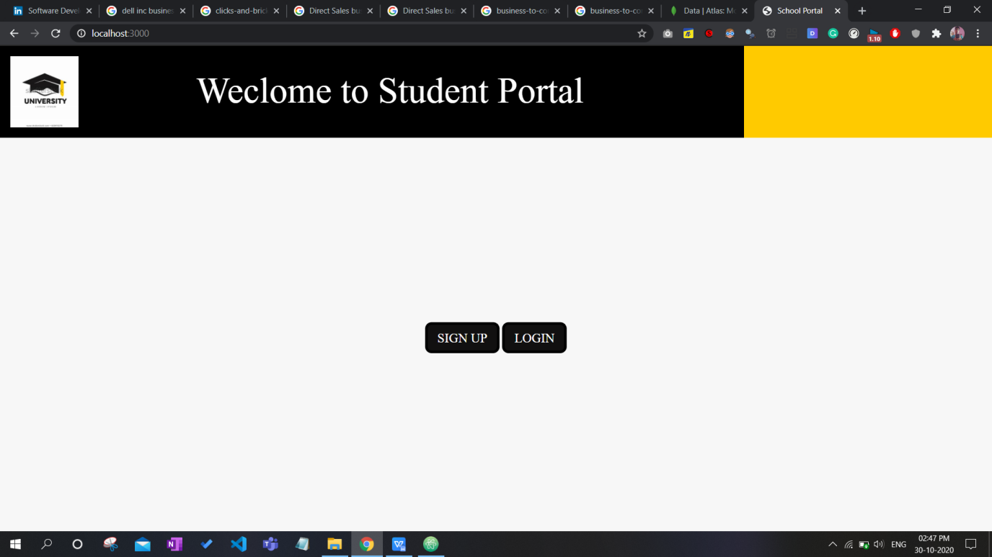

Sign up page-

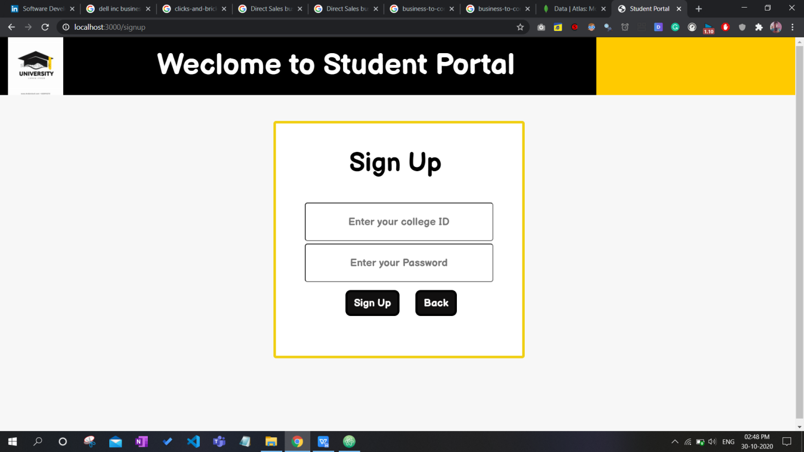

User Login page-

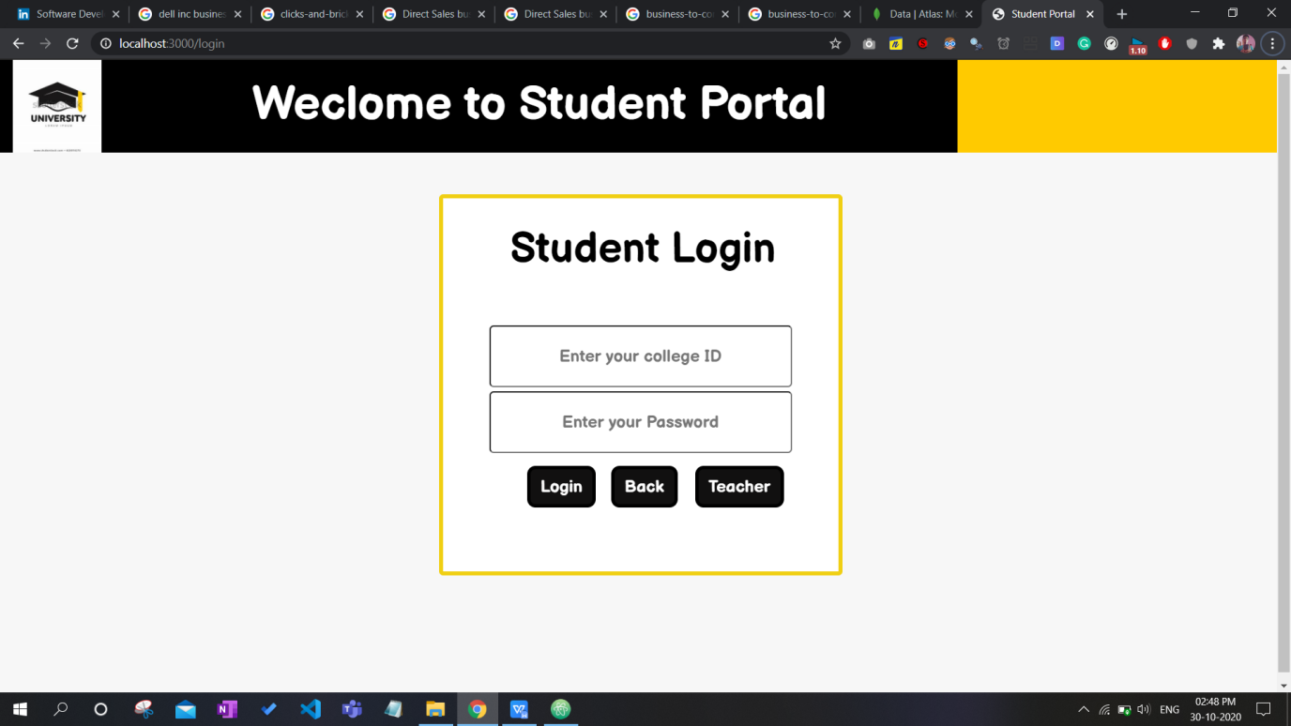

Teacher Login-

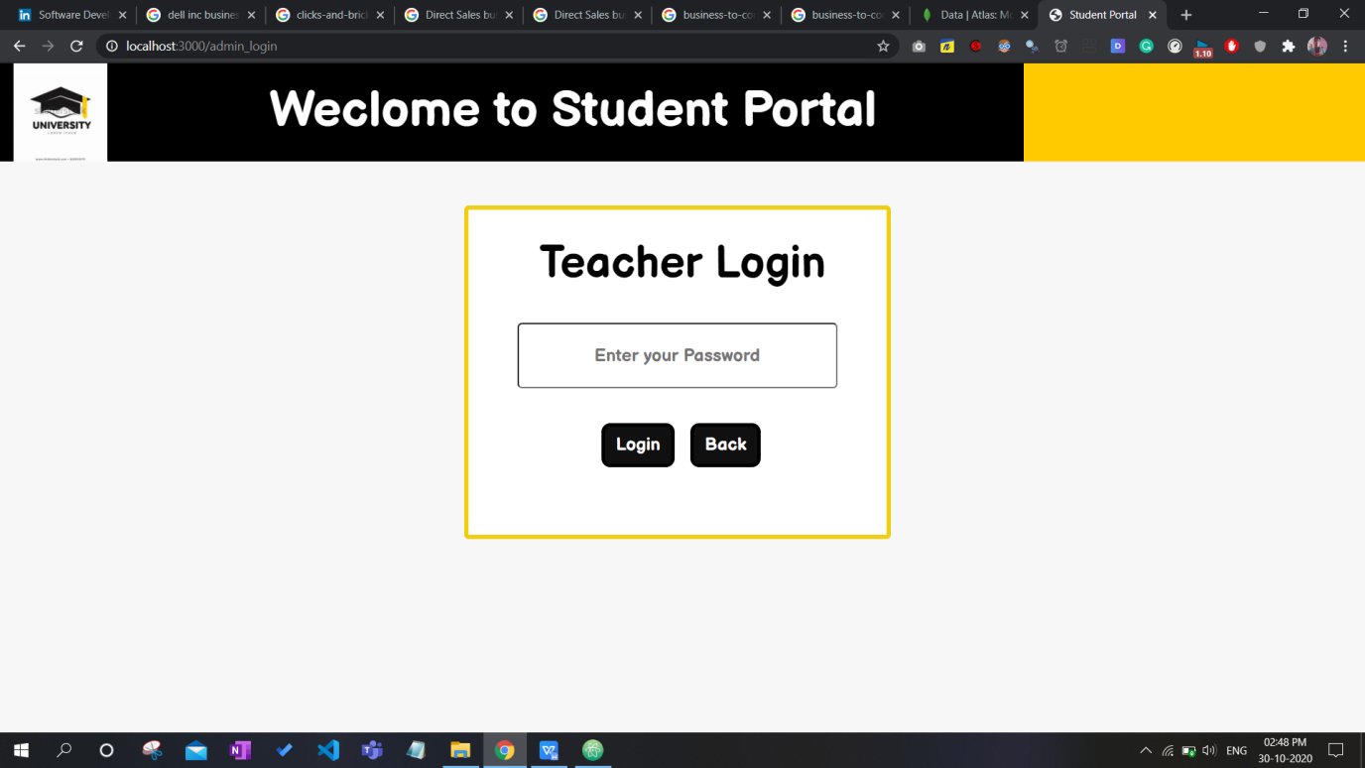

Login from account of 1 user-

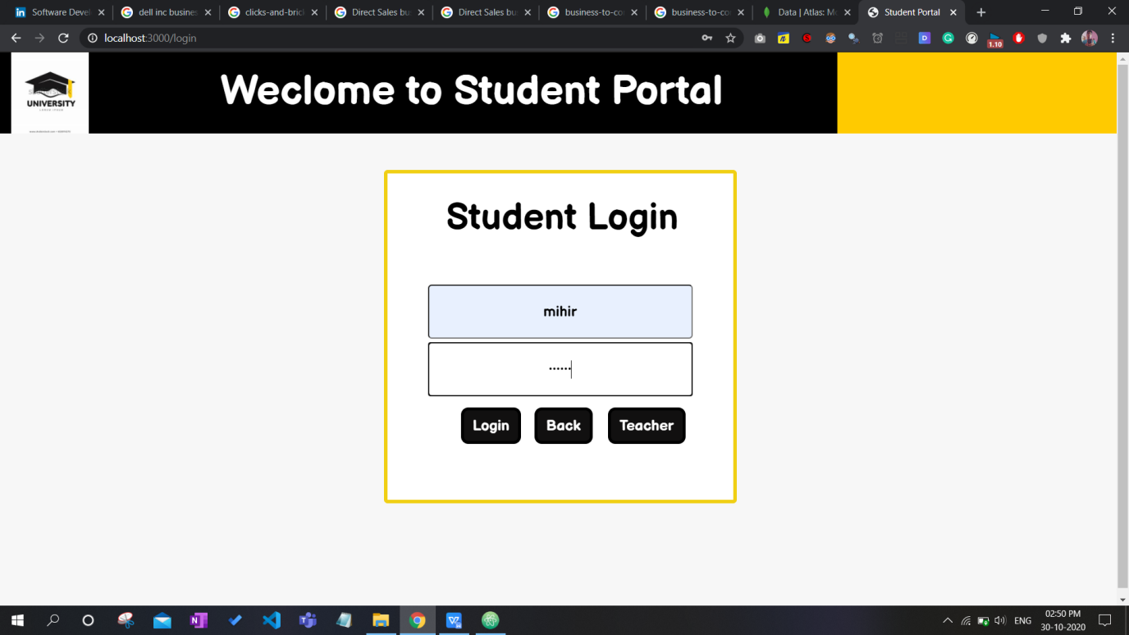

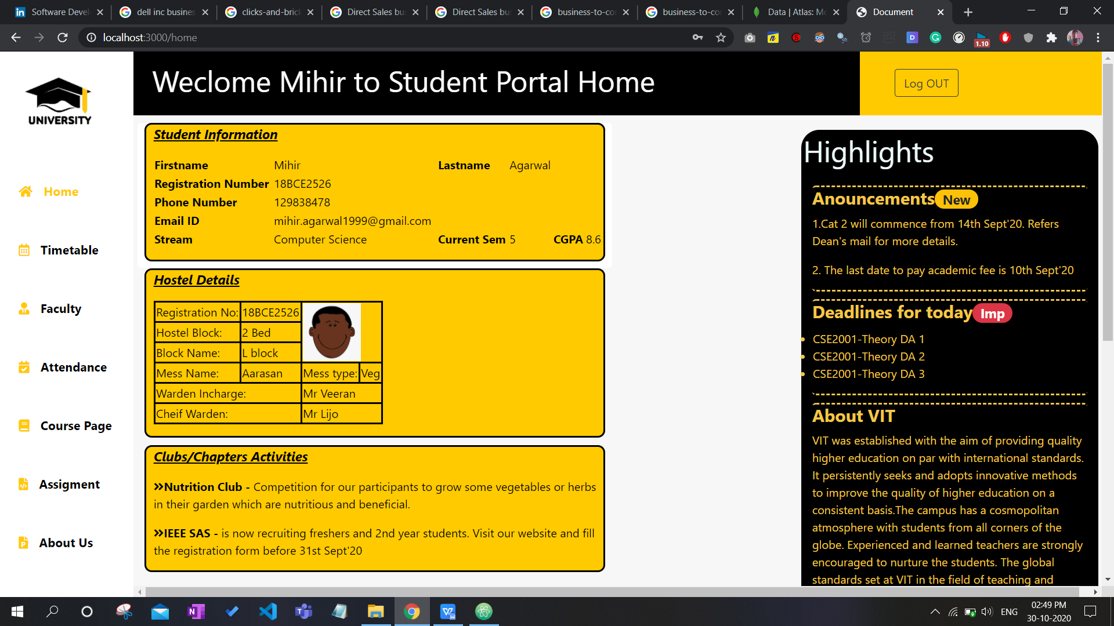

Login from account of 2 user-

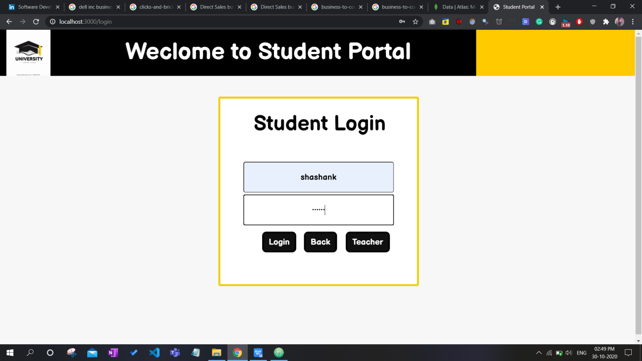

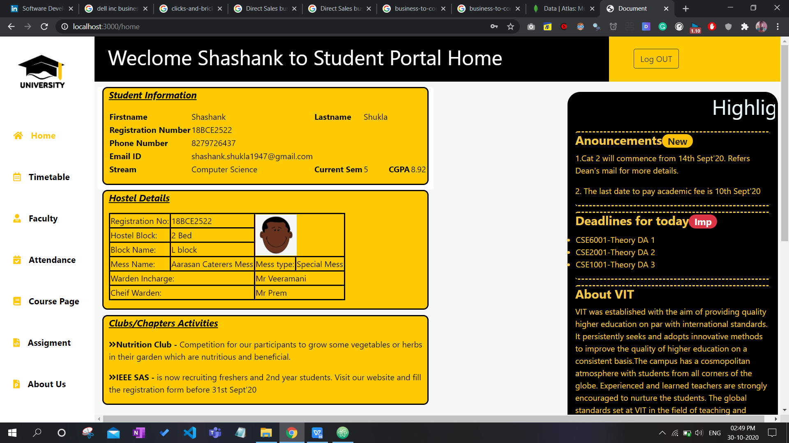

All remaining pages-

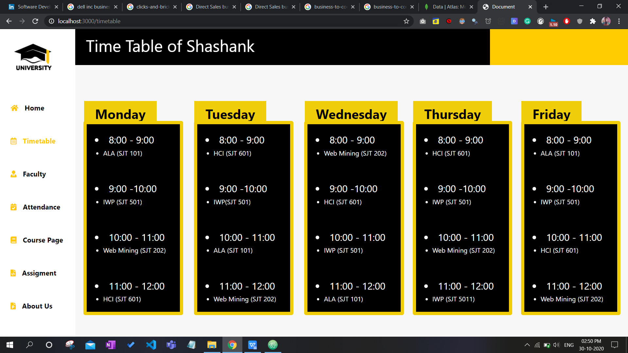

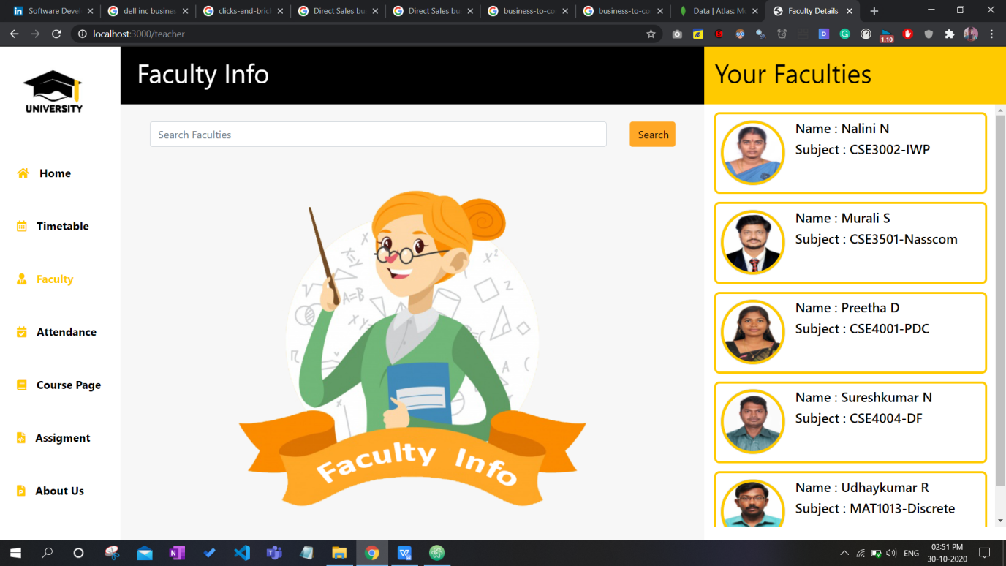

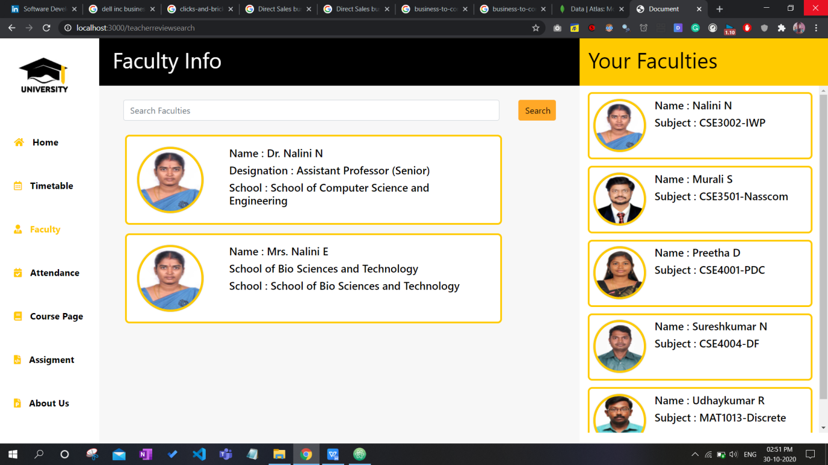

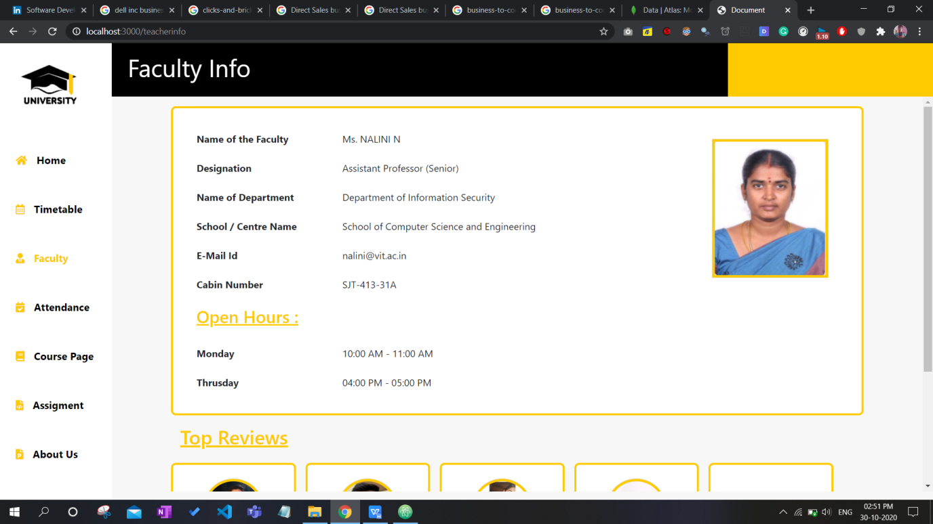

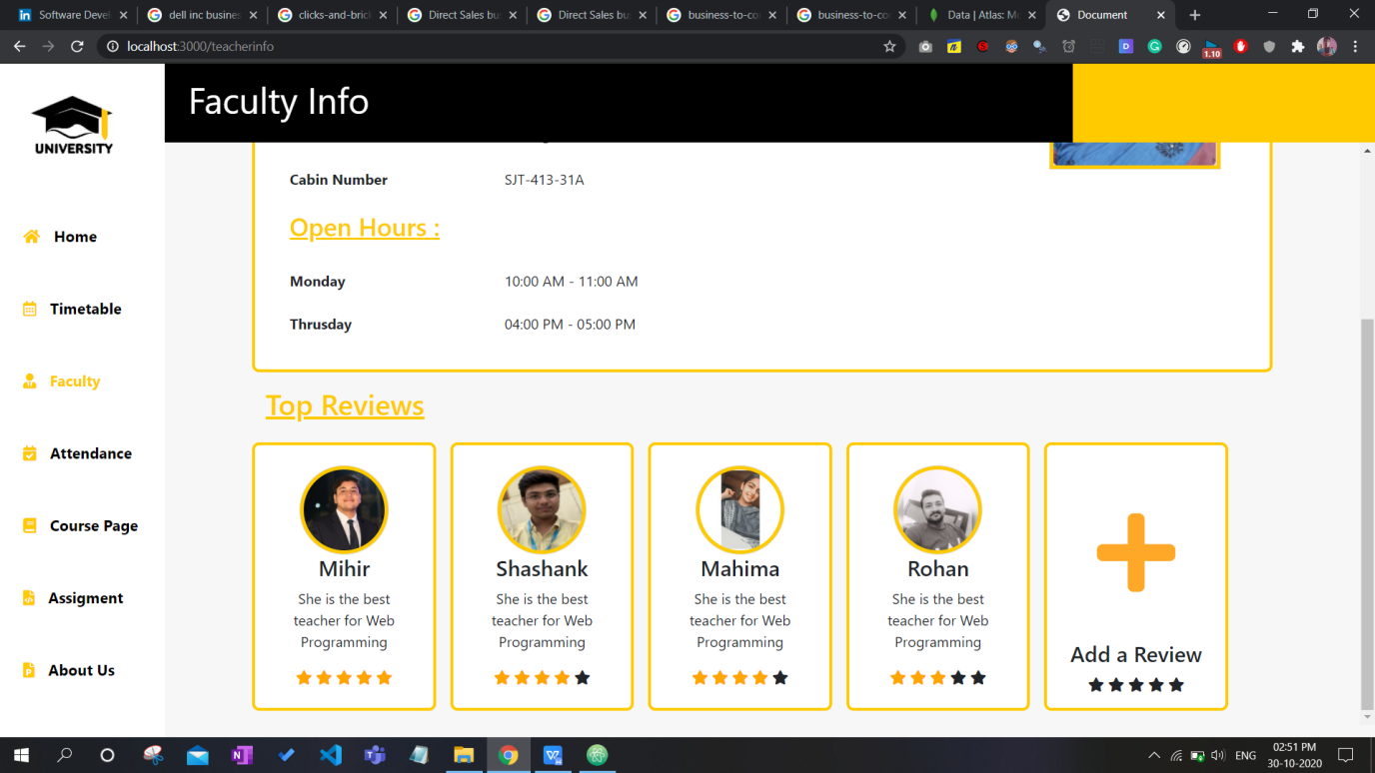

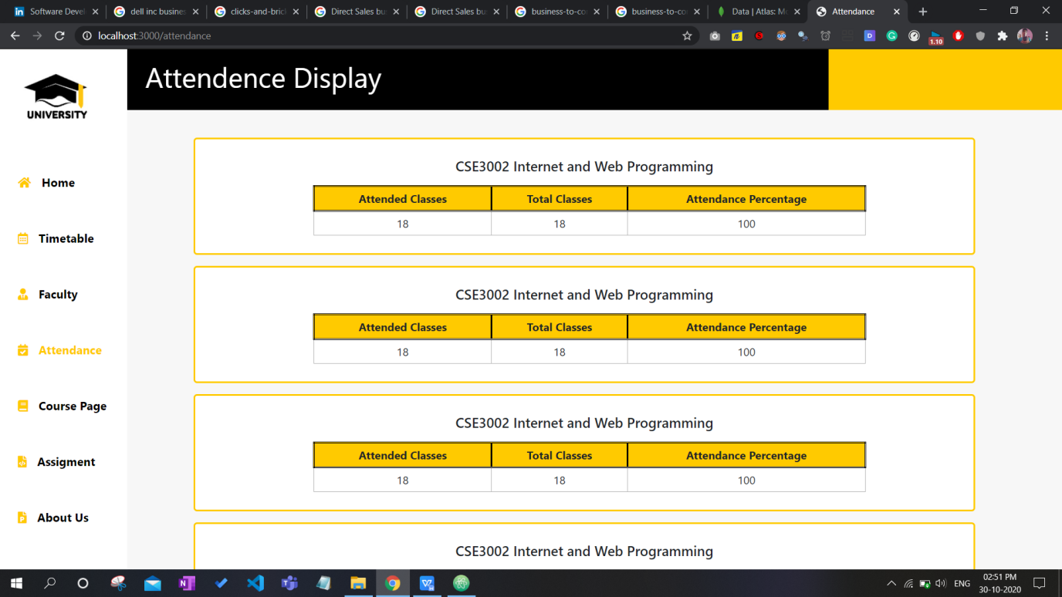

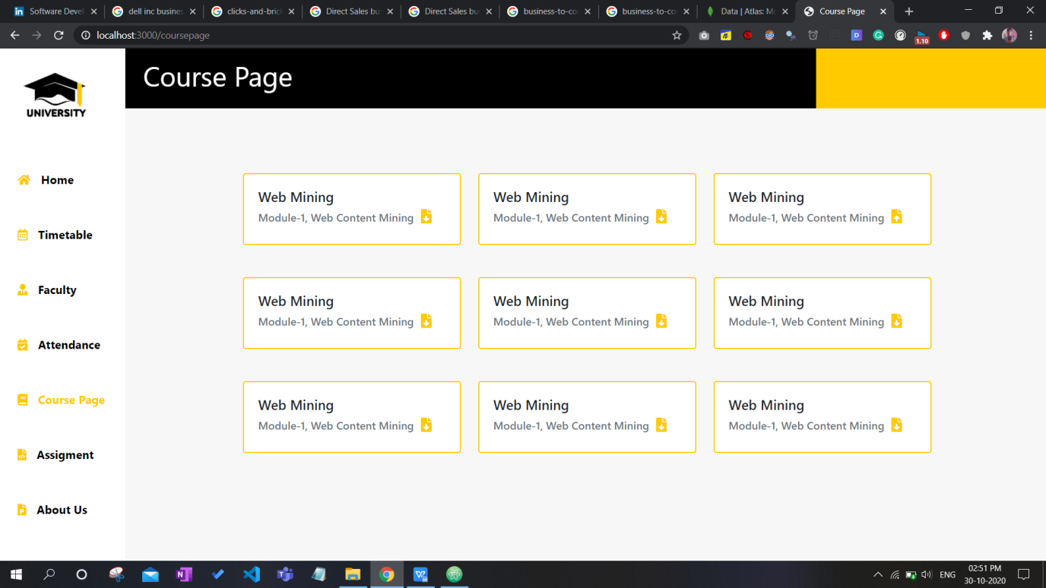

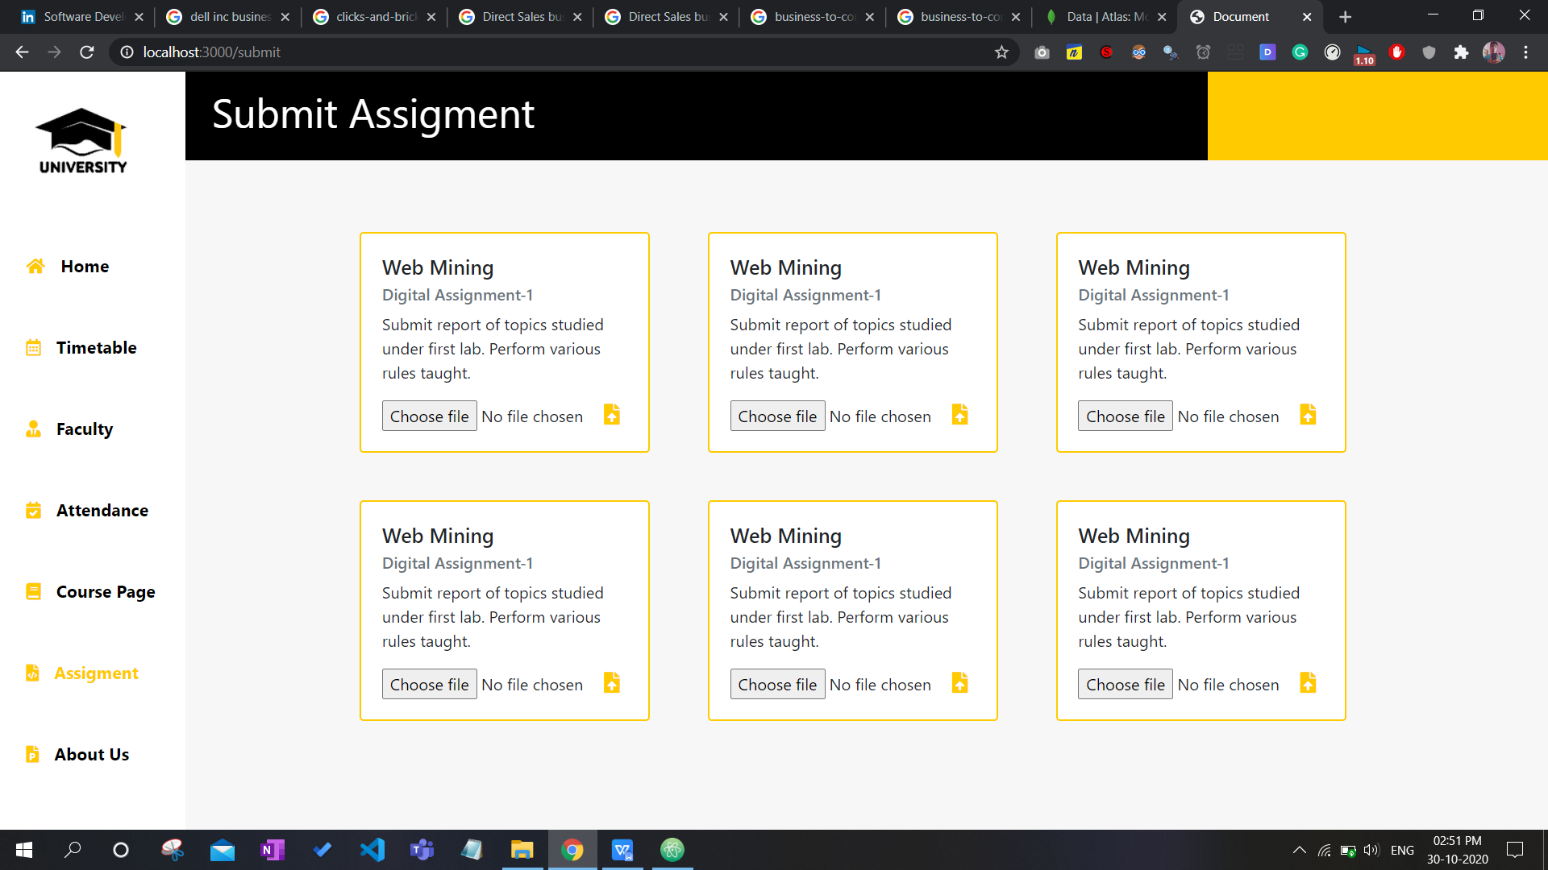

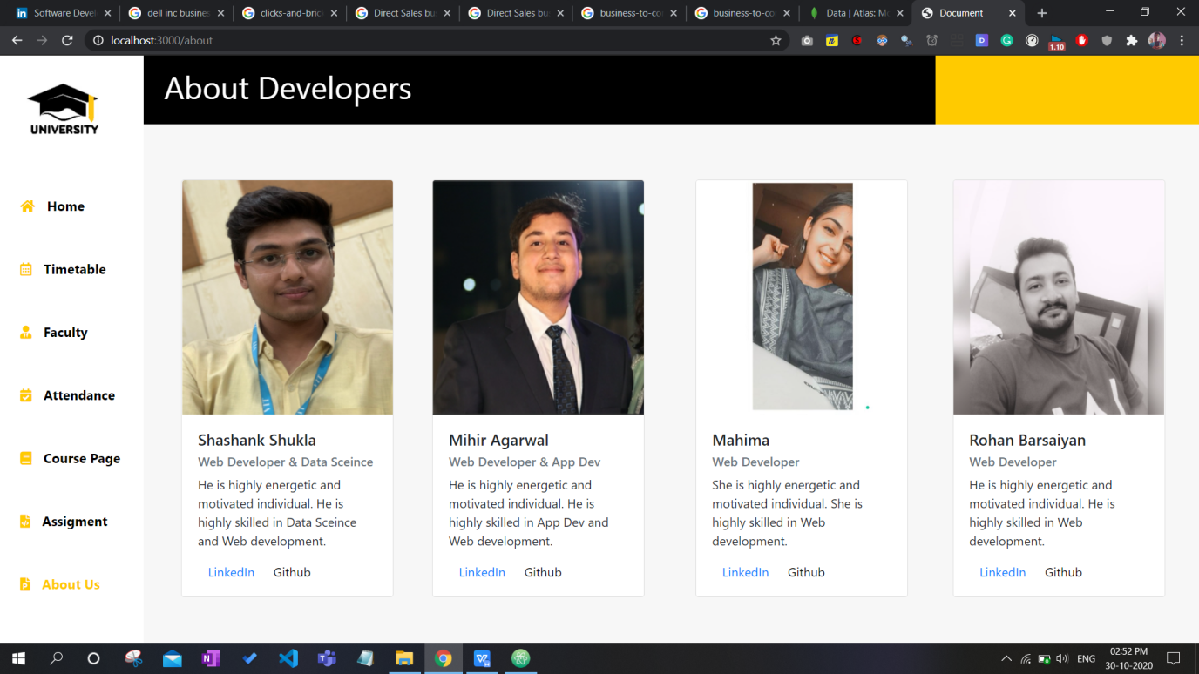

File upload from user 1-

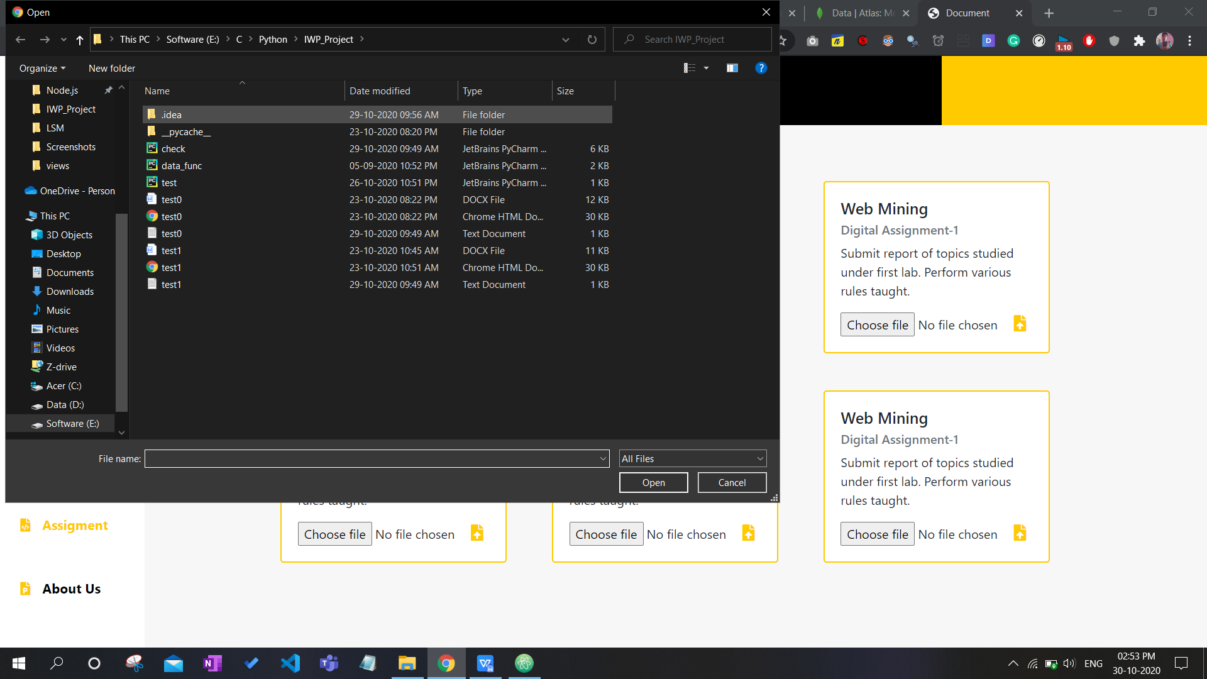

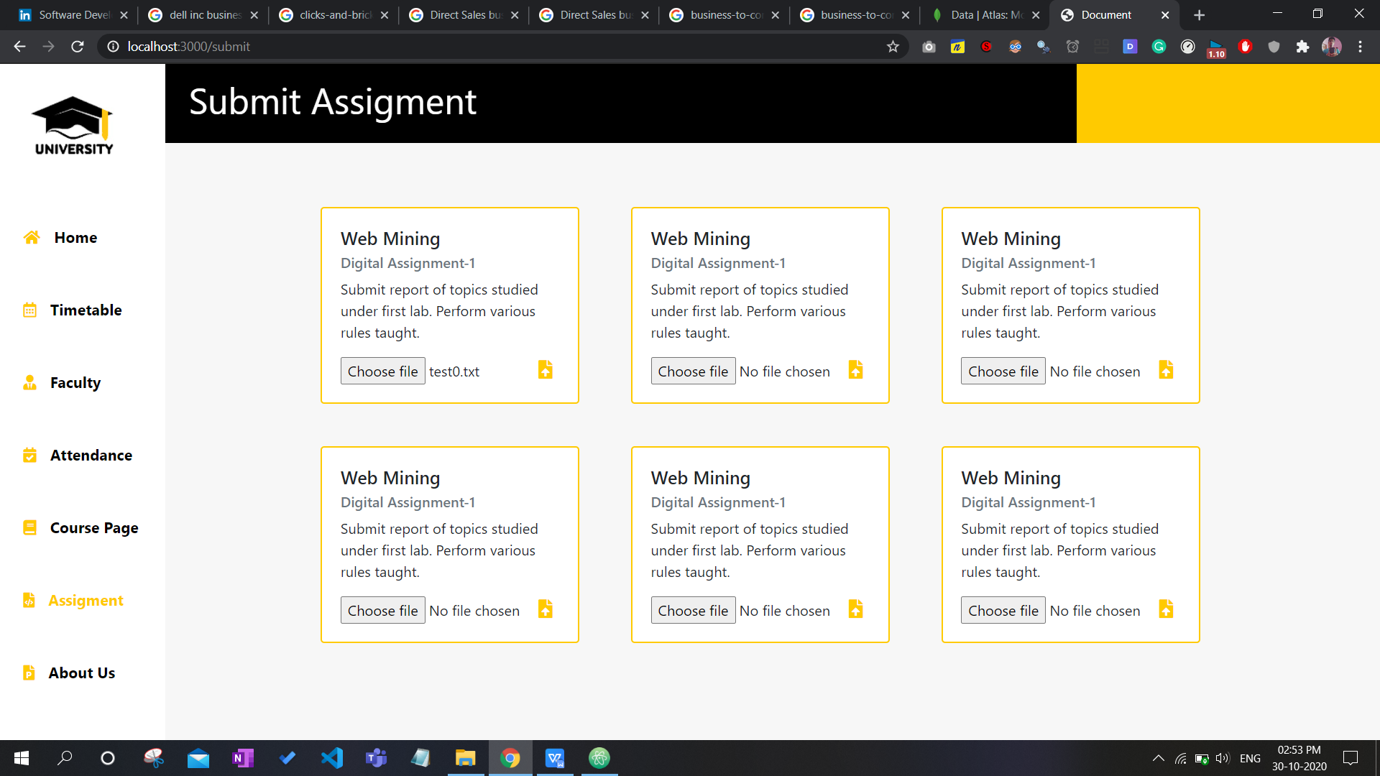

File upload from user 2-

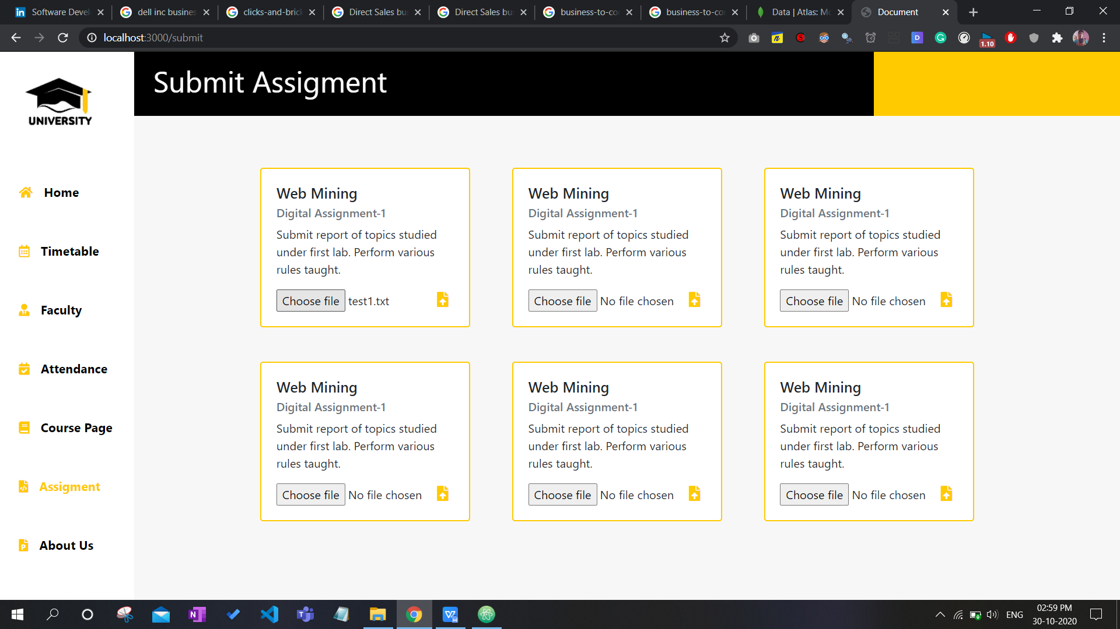

Both the files in database, uploaded as chunks-

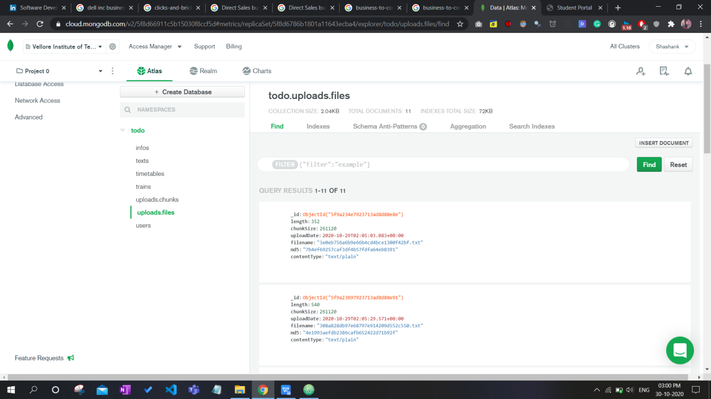

To check plagarism from teacher login-

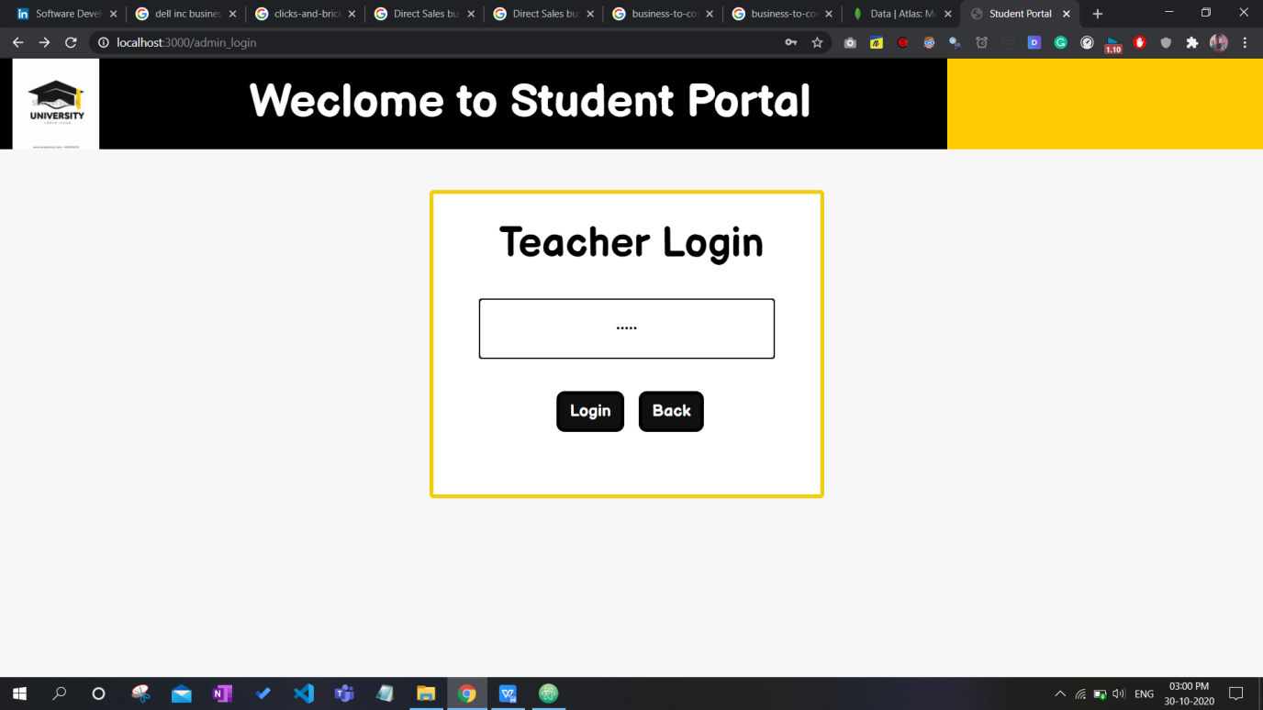

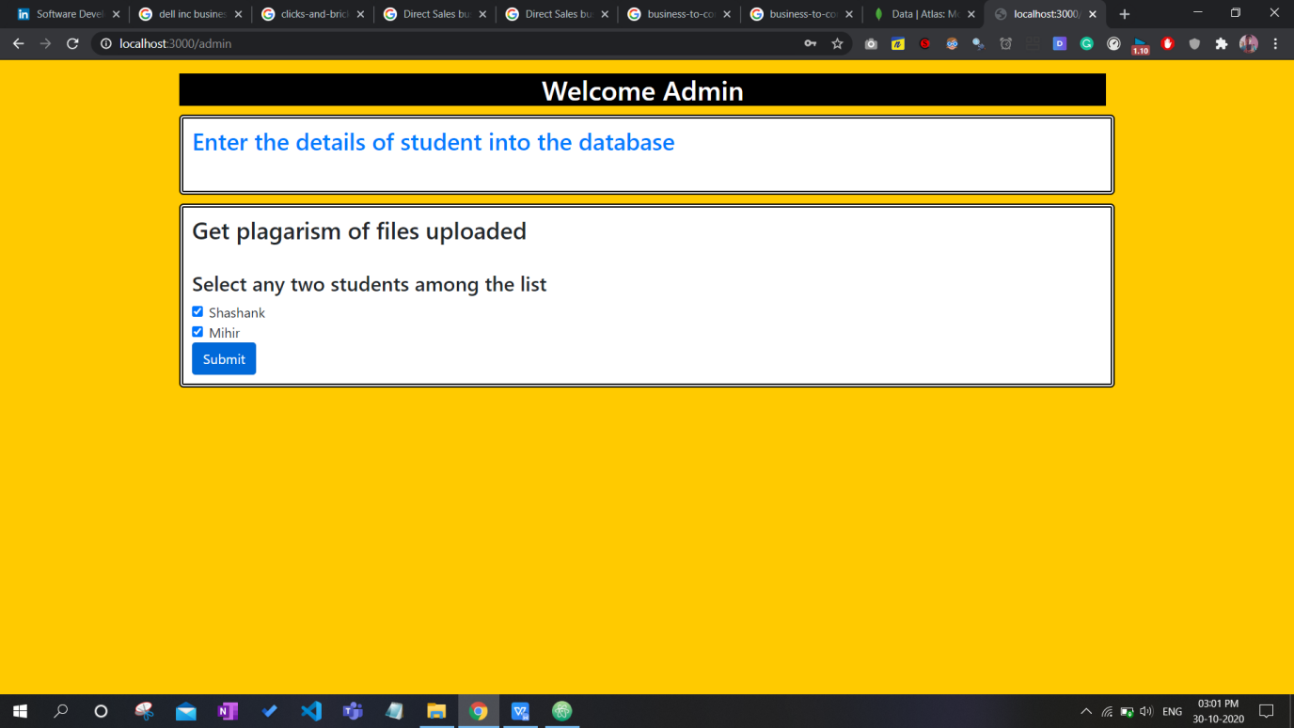

Final output of plagarism displayed on web page-

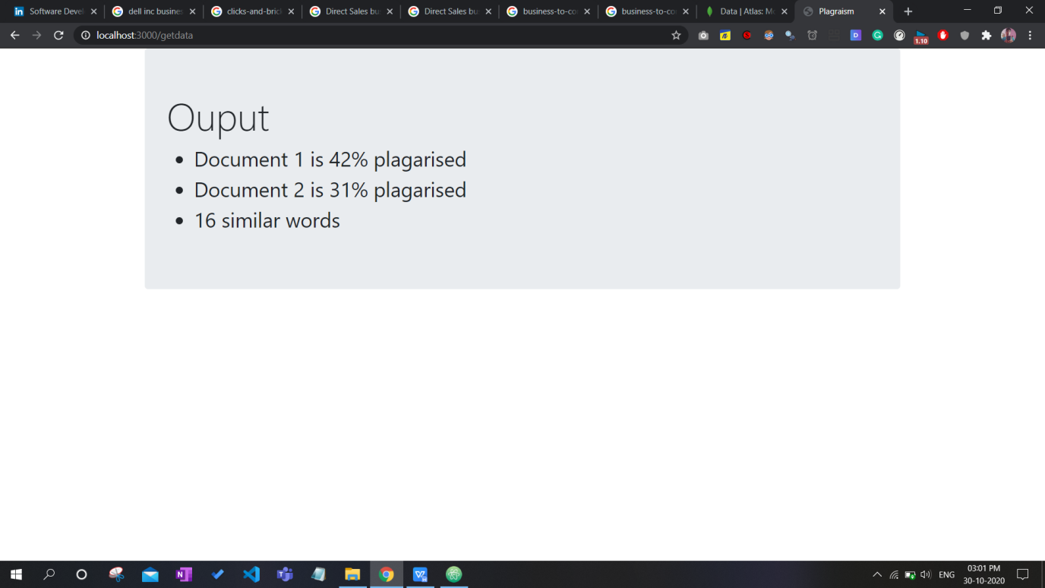

Plagarism on online website for the same 2 documents uploaded-

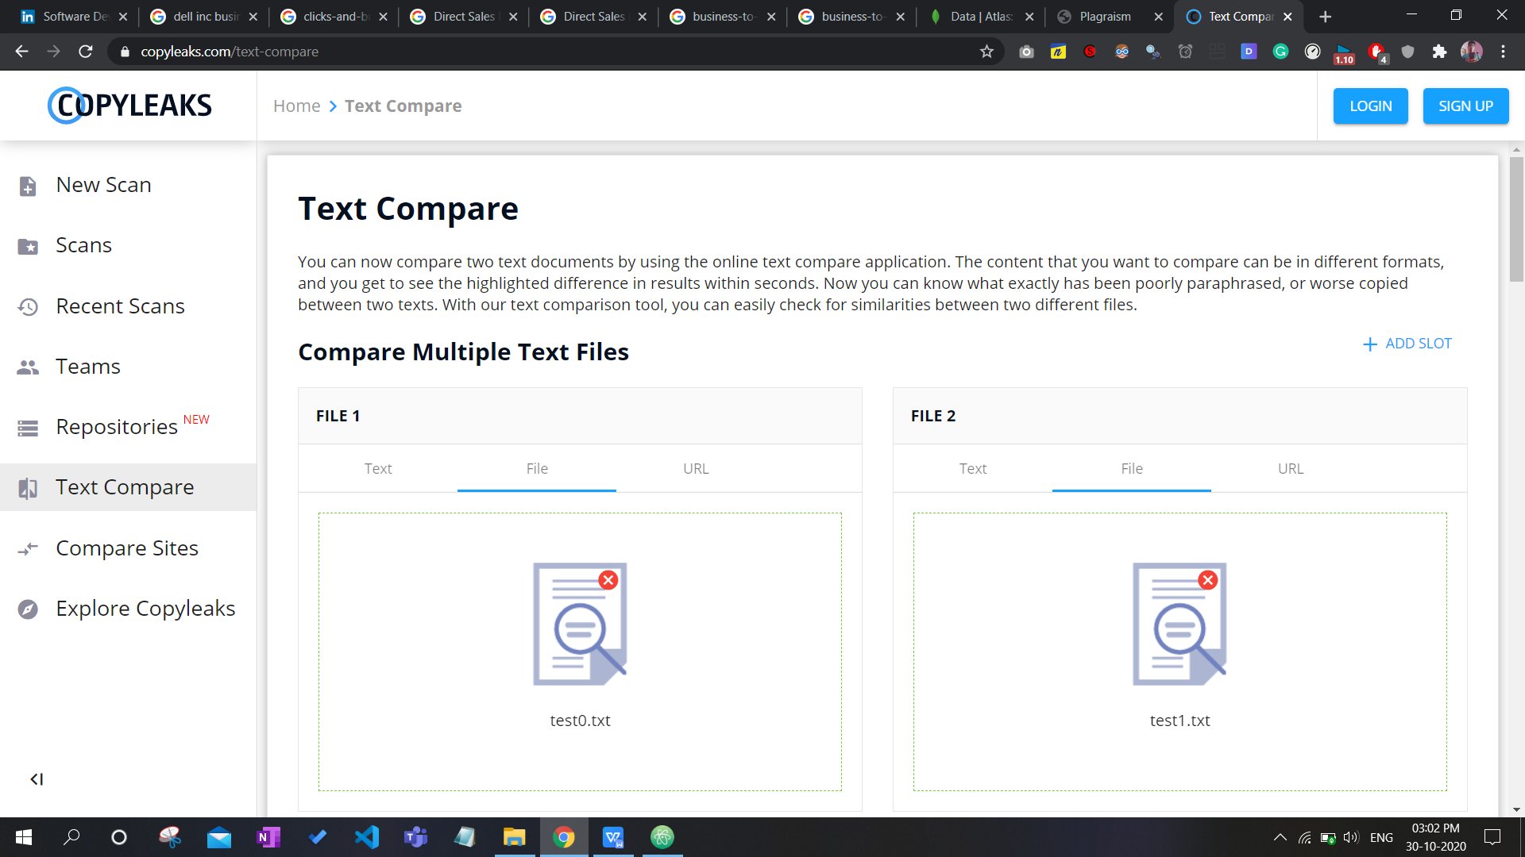

Output-

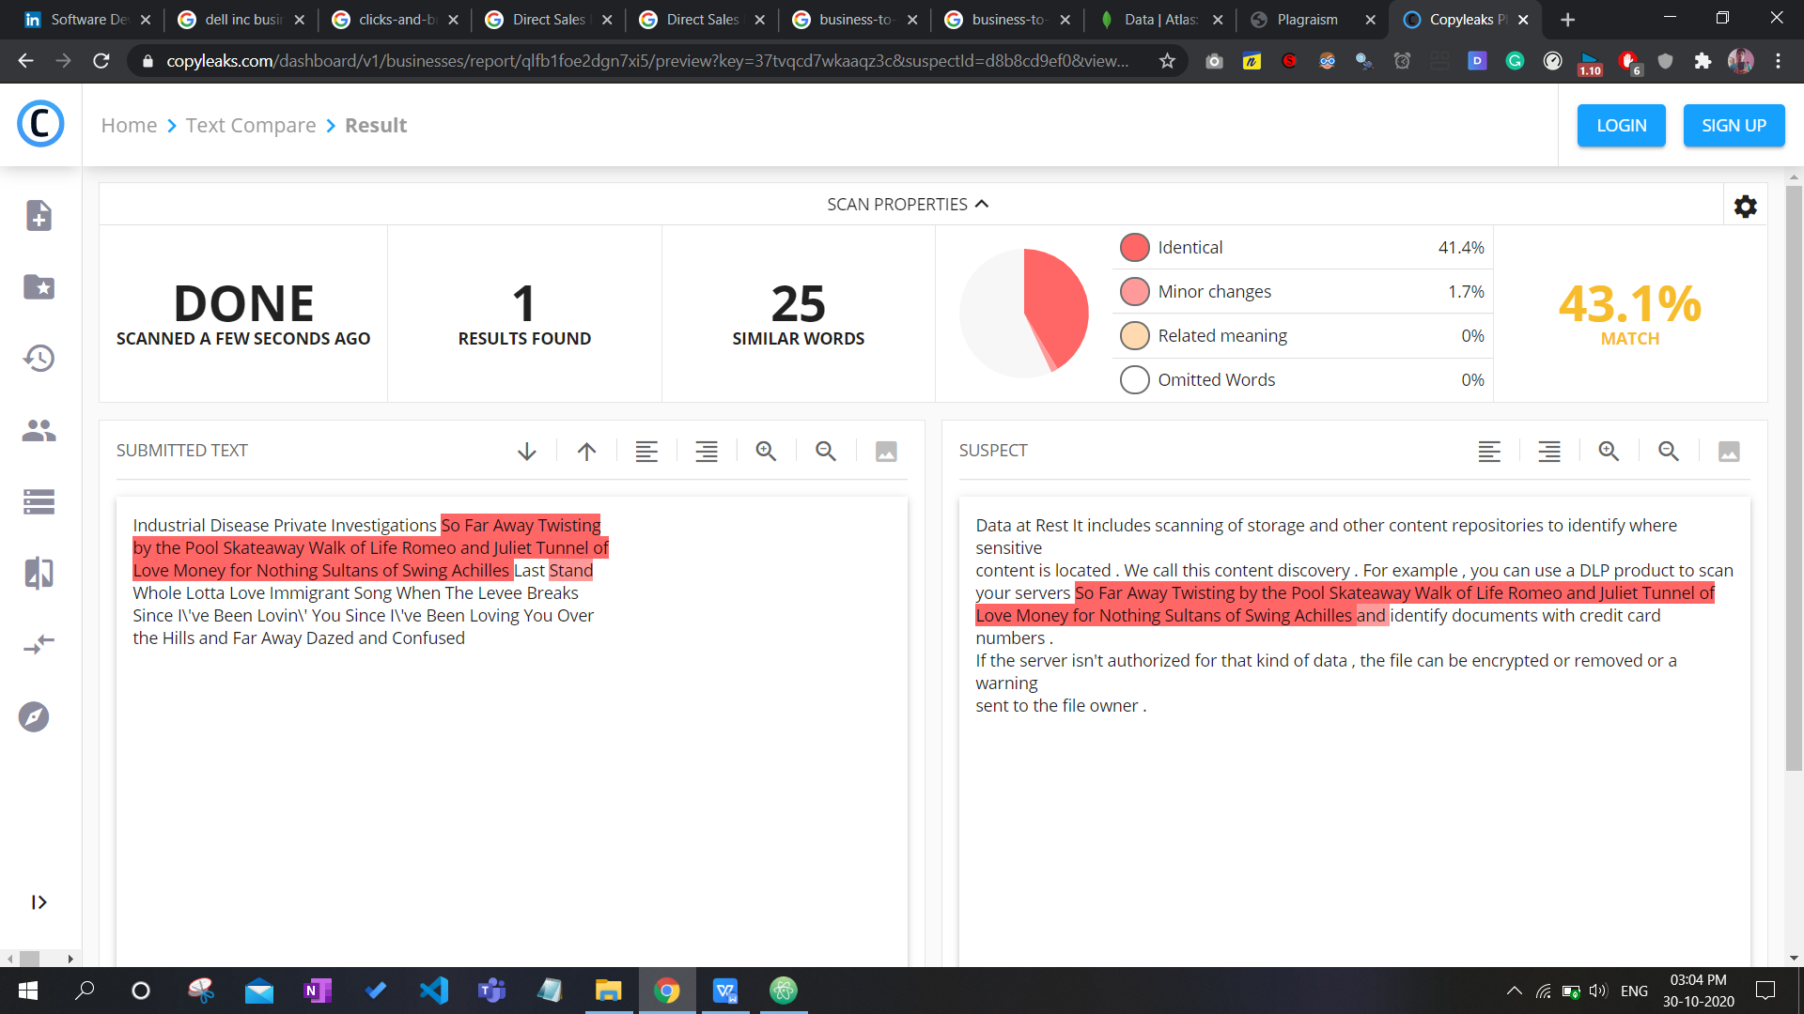

We can see result is almost same, its 25 in website as they are comparing stop words like “the”, “or” ,“and” also but we have removed them compared only core words hence its actually 16.

Registering new user-

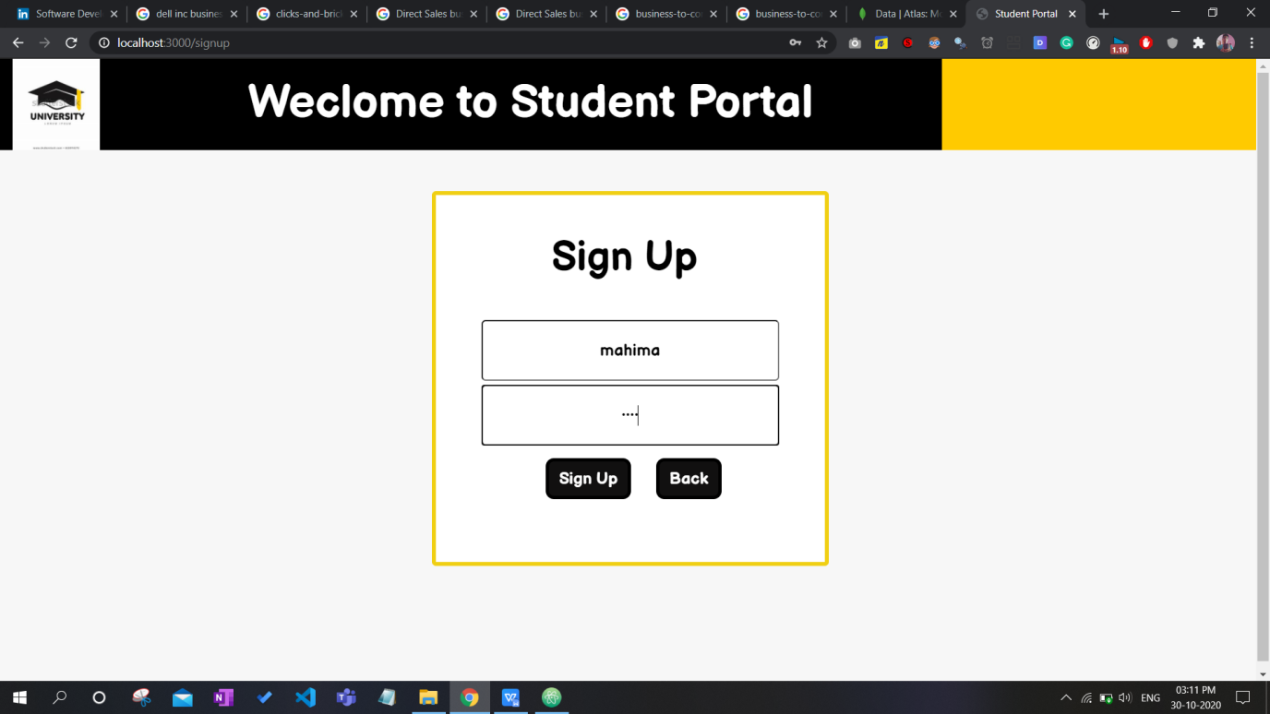

Details gets added into database-

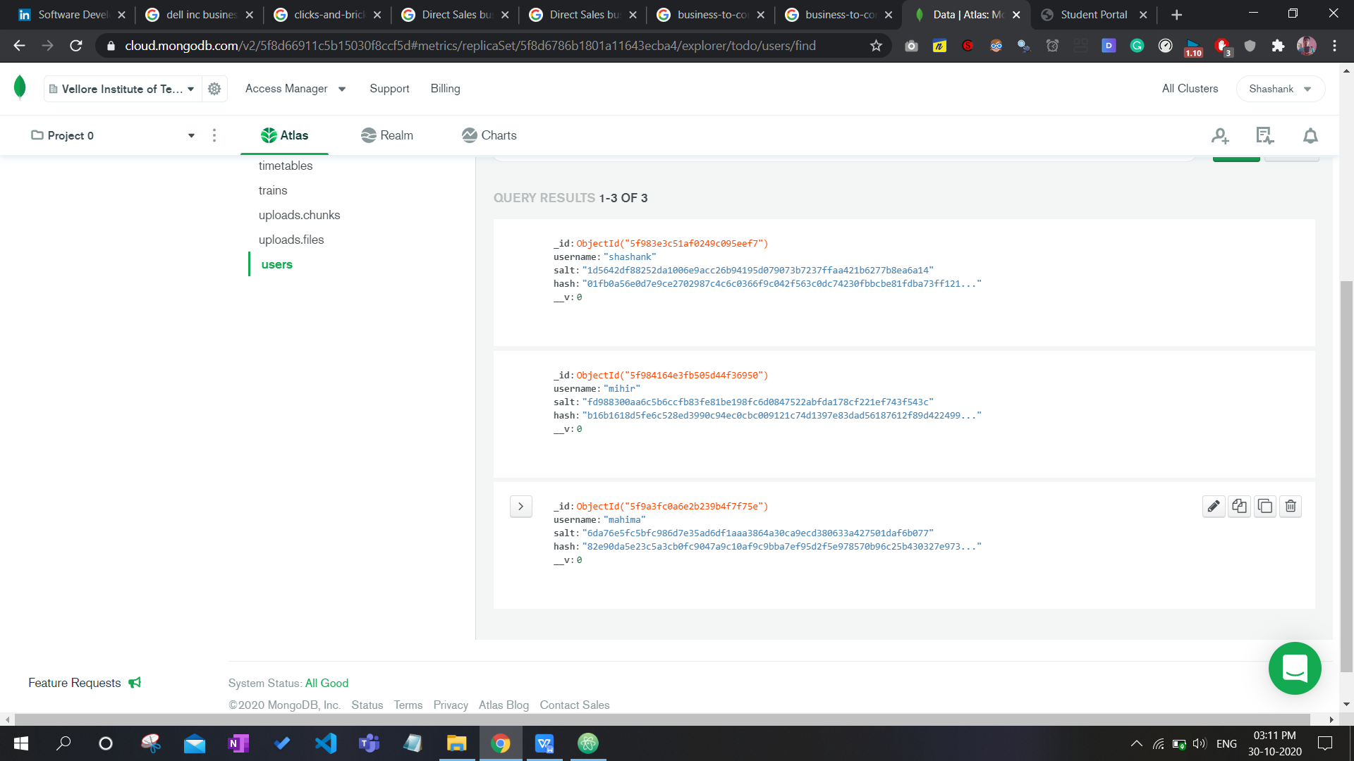

No information for new user-

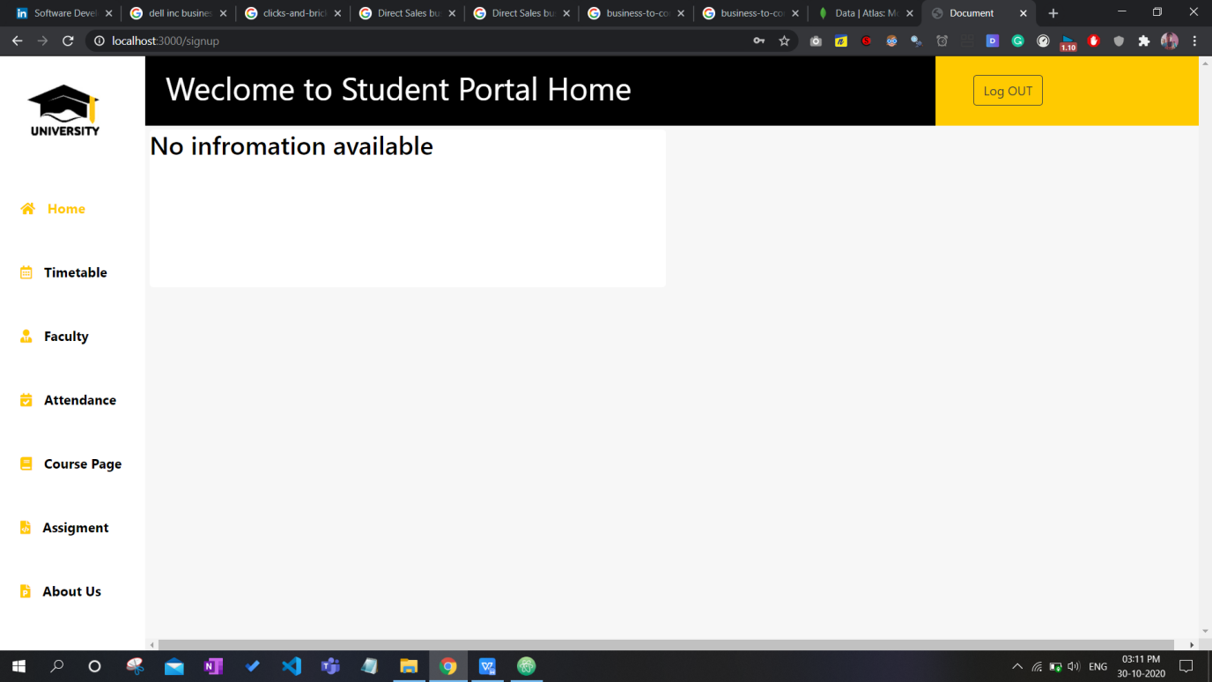

Entering data for new user from teachers login-

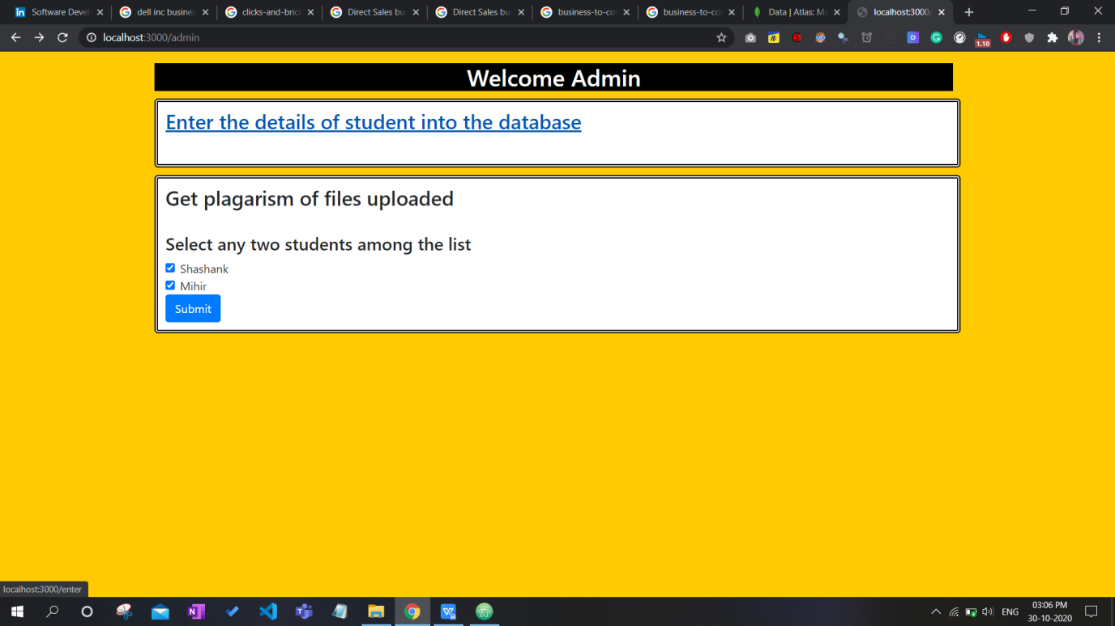

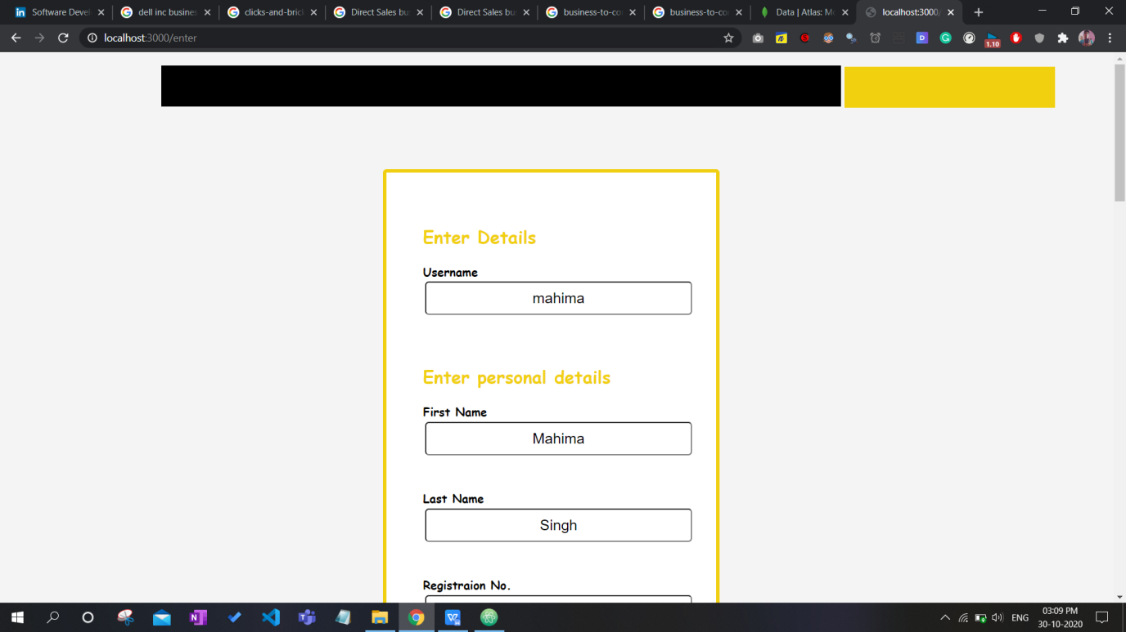

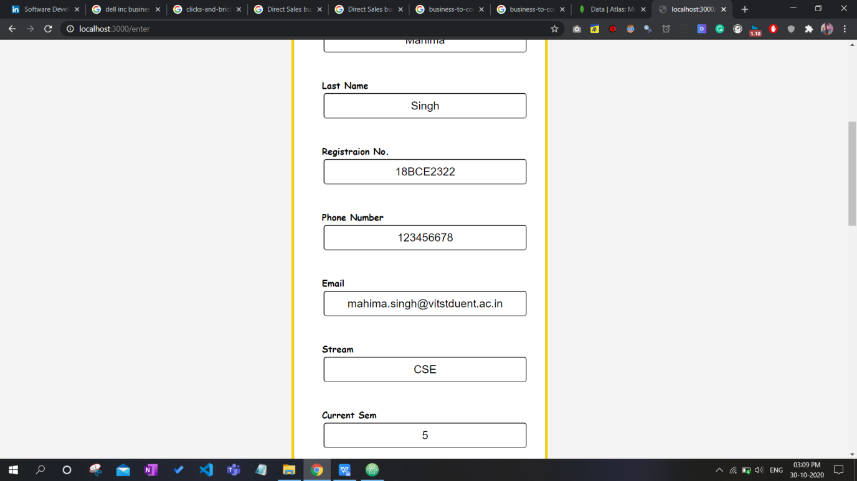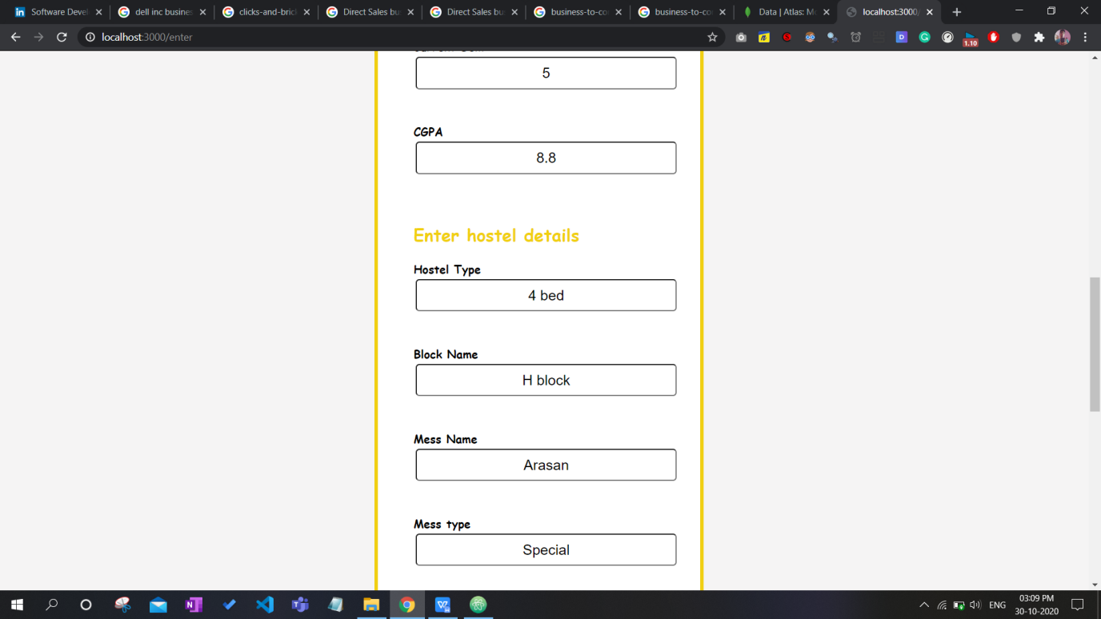

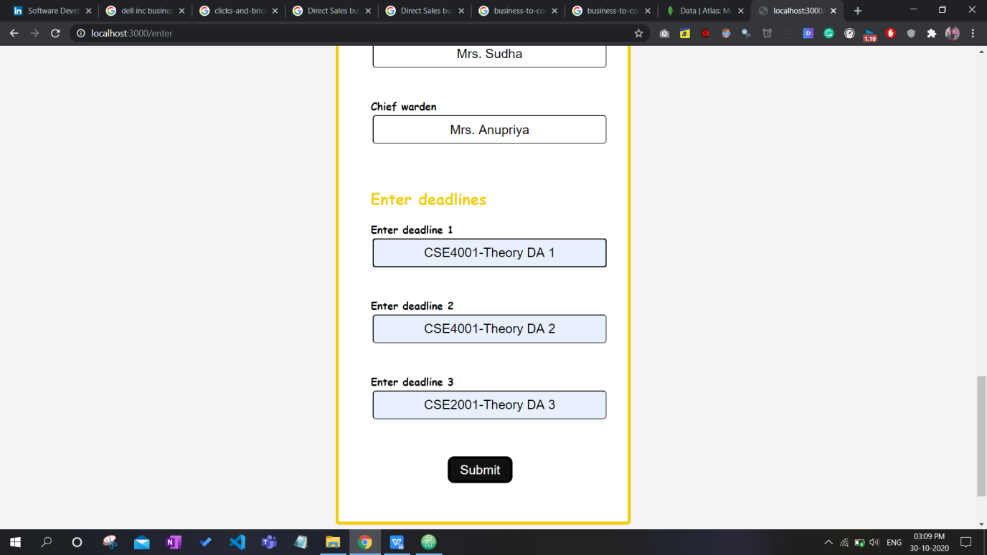

Details are added dynamically into homepage-

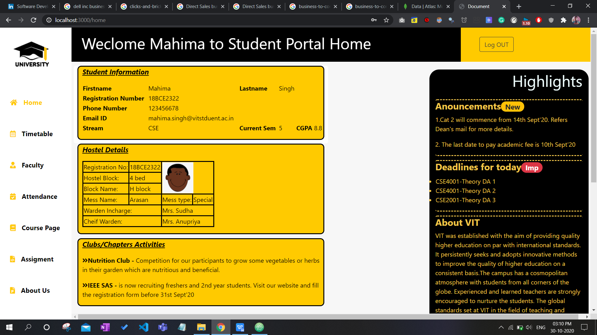

Data added into the database successfully-

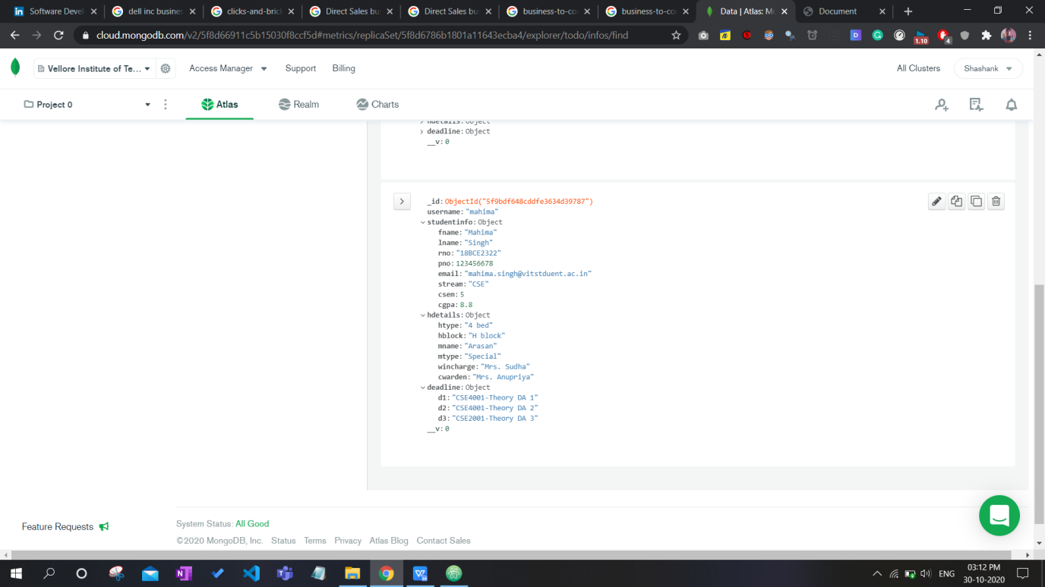

1. **CONCLUSION /FUTURE WORK**

Conclusion :

It is an advantage for the consumers whose considerable time and energy is maintained, for the authority of the affected educational college whose workload is significantly reduced, whose facilities are shielded from misuse.

This system will also be used to view the full syllabus/course material, update the user's information(only by the faculty). Using this site will dramatically minimise the sharing of engineering document time.

The teacher will be able to check the novelty of the work uploaded by the student using the plagiarism checker.

Future Work:

We plan to extend the portal for parents as well, so that they can keep a track of their child’s academics status.

Apart from the academic facilities we aim to extend the project to allow transfer of fees, to keep a record of the receipts and any other outstanding dues.

**APPENDIX A (CODES)**